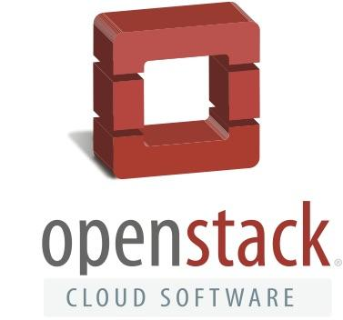

FACT SHEET

What is OpenStack?
The OpenStack project is a global collaboration of developers and cloud computing technologists producing the open standard cloud computing platform for both public and private clouds. Hundreds of the world’s largest brands - including AT&T, Bloomberg, Best Buy, Comcast, eBay, PayPal, SAP, Time Warner Cable, Verizon, Visa, Walmart, Wells Fargo, and Yahoo, just to name a few - rely on OpenStack to run their businesses every day, reducing costs and helping them move faster.

Companies large and small are using OpenStack through a range of consumption models for a variety of workloads. OpenStack is used by 50 percent of the US Fortune 100, spanning industries including financial services, manufacturing, media, government/university research, retail, technology & telecom.

Launched in 2010, the OpenStack project, one of the fastest growing open source communities in the world, is backed by a vibrant community of developers and some of the biggest names in the industry. To date, over 20 million lines of code have been contributed by more than 54,400 people; nearly 600 supporting companies in 180 countries.

What does OpenStack software do?
OpenStack software is a cloud operating system that controls large pools of compute, storage, and networking resources throughout a datacenter, managed through a dashboard or via the OpenStack API. OpenStack works with popular enterprise and open source technologies making it ideal for heterogeneous infrastructure. As an open and interoperable platform that is widely deployed in public and private clouds around the world, OpenStack is the best infrastructure to build and run applications to enable portability and leverage of a large ecosystem of tools and services

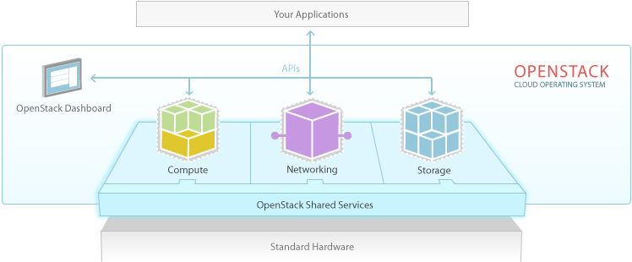

OpenStack has become the cloud platform of choice for enterprises and service providers, as an integration engine to manage diverse cloud technologies and use cases, bringing together VMs, bare metal and containers in one platform. Users typically start with web services and cloud native applications, and then onboard their legacy and specialized applications, picking the best technologies for their workload.

What is the role of the OpenStack Foundation?
The OpenStack Foundation, the global independent home for OpenStack, promotes the global development, distribution and adoption of the OpenStack cloud operating system. The goal of the OpenStack Foundation is to serve developers, users, and the entire ecosystem globally by providing a set of shared resources to grow the footprint of public and private OpenStack clouds, enable technology vendors targeting the platform and assist developers in producing the best cloud software in the industry. Like the software, individual membership within the OpenStack Foundation is free and accessible to anyone. Individual Members are expected to participate in the OpenStack community through technical contributions or community building efforts.
How does the OpenStack design and development process work?
The community operates around a six-month, time-based release cycle with frequent development milestones. During the planning phase of each release, the community gathers for a Design Summit to facilitate live developer working sessions and assemble the roadmap. The most recent Design Summit for Newton, the 14th release of the software, was held in Austin, Texas, in April of 2016. The next Design Summit (for the Ocata release) will be held in conjunction with the global OpenStack Summit in Barcelona, Spain, October 25-28, 2016.
Additional Resources
- How to get started with OpenStack
- The OpenStack Marketplace
- OpenStack Foundation News
- Superuser Magazine

