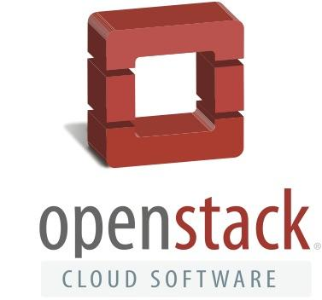

OpenStack Foundation

Executive Bios

Jonathan Bryce, Executive Director
Jonathan Bryce, who has spent his career building the cloud, is Executive Director of the OpenStack Foundation. Previously he was a founder of The Rackspace Cloud.
Jonathan started his career working as a web developer for Rackspace, and during his tenure, he and co-worker Todd Morey had a vision to build a sophisticated web hosting environment where users and businesses alike could turn to design, develop and deploy their ideal web site – all without being responsible for procuring the technology, installing it or making sure it is built to be always available. This vision became The Rackspace Cloud. Since then he has been a major driver of OpenStack, the open source cloud software initiative.
Mark Collier, Chief Operating Officer
Mark Collier is the Chief Operating Officer of the OpenStack Foundation. He has been involved with OpenStack since its birth within Rackspace, where he served as vice president of business development and corporate development. In this capacity he played an instrumental role in the company’s initiatives to fully embrace open source in the cloud and to build alliances with NASA and 25 other organizations. Prior to that, Mark had a senior business development position at Yahoo! and product, marketing, and technical roles at Dell.
With the launch of OpenStack in July 2010, Mark’s focus shifted to full-time community building activities to grow OpenStack, and he provided principal leadership to the establishment of the independent OpenStack Foundation in the Fall of 2012. Mark is passionate about furthering the mission of the OpenStack Foundation, especially with respect to serving the needs of users of the software.
Lauren Sell, Vice President, Marketing and Community Services
Lauren Sell is the Vice President, Marketing and Community Services for the OpenStack Foundation. She helped launch OpenStack in 2010 and has since focused on building the brand and global community around one of the largest and most successful open source projects to date. She is passionate about the community and has been working closely with OpenStack users, technical contributors and marketers to bring the OpenStack story to life and drive global adoption. Lauren has been marketing in the technology industry for more than twelve years, with a background in early stage companies, open source and enterprise software, as well as industry events like SXSW Interactive.

