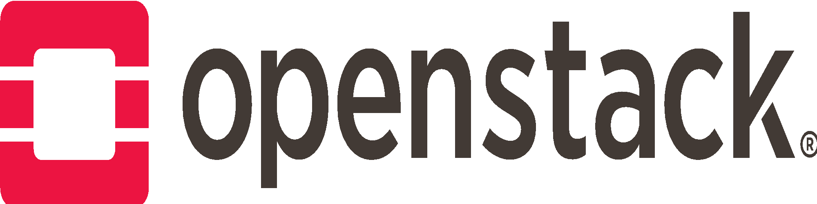

OpenStack Days 2018 Policy and Guidelines Document

Event Name: OpenStack Days ________________________ (e.g. OpenStack Days China)
Event Tag Line: _____________________________________________________________
Event Location (City, State/Country): ____________________________________________
Event Date(s): __________________________

We (enter your full names) _______________________________,_______________________________,
and _______________________________, _______________________________, understand and agree to the following the policies and guidelines as presented below:
- We are the main organizers and points of contact for the OpenStack Days Community event referenced above.
- The purpose of the event must be to educate and inform, NOT to sell products or services.
- Please review the OpenStack Days website. This website contains a lot of important information about hosting an OpenStack Days event.
- The intent of the event is NOT to generate a profit. Sponsorships are allowed, but only to cover hard costs of producing the event. Any profit generated from the event is expected to be invested in future OpenStack community events or activities.
- Attendees may be charged a registration fee but the amount must be minimal; less than $100 USD is strongly recommended. Consider offering special pricing such as early bird registration, diversity and scholarship promotional pricing.
- In order to be considered an official OpenStack Day event, the event must be at least a 1 day event with a minimum of 150 attendees.
- In order to keep with the open community aspect of running an OpenStack Days event, we require a minimum of three sponsor companies to participate in the organization of this event. 3 sponsors are required before any event promotion or planning can begin or Foundation financial support can be requested; a minimum of four sponsoring companies for the event is highly encouraged. Please provide the following information when submitting this agreement:

  - Sponsor Company #1
    - Company Name:
    - Contact Name:
    - Contact Email:
  - Sponsor Company #2
    - Company Name:
    - Contact Name:
    - Contact Email:
  - Sponsor Company #3
    - Company Name:
    - Contact Name:
    - Contact Email:
  - Sponsor Company #4 Name
    - Company Name:
    - Contact Name:
    - Contact Email:

- Equal opportunity for sponsorship is required, including competitors of the organizing company. A best practice is to publish a sponsorship prospectus online in advance with sponsorships filled on a "first to sign" basis.
- The event should be published and attendance should be completely open to the public, the only restrictions being venue capacity.
- The attendee list may NOT be used for commercial or marketing purposes, only community-building activities, such as sharing event updates or scheduling future meetups. The list will not be shared with third parties who are not directly involved in organizing the event. Please review OpenStack’s Privacy Policy Statement.
- We recommend you add the following statement to your registration page:
“Personal information gathered by the OpenStack Foundation is handled in accordance with the Foundation’s Privacy Policy and is used for internal purposes only. The OpenStack Privacy Policy is available at http://www.openstack.org/privacy.”
- In order for the Foundation to gather consistent demographic information, we are asking that you add the following question to your registration page. Please include this information and any other survey information to the Foundation when you send in post event information.
What is your current Organizational Role at your company? (please check one):
- Business Development / Sales / Marketing
- CEO / Executive Leadership
- CIO / CTO / IT Manager
- Cloud Application Developer
- Cloud Architect
- Engineer
- OpenStack User / Operator
- Operations / SysAdmin
- Product Management
- Product Strategy
- Upstream Developer
- Other, please specify
- OpenStack Days Advisory Board: In order to demonstrate that this is an open community event, you are required to create an advisory board that consists of at least 4 people from 4 different companies or organizations. This Advisory Board must be posted on the OpenStack Days website.
- OpenStack Days Registration List: Please add events@openstack.org as an administrator for any tools used to organize the event, such as Meetup.com, Eventbrite, etc. so that the OpenStack team can help the organizers when needed, and provide the Foundation with easy access to your registration list. Your registration list should include the attendee name, email, title, and company name in addition to the responses to the demographic survey question requested above.
- Due to the twice annual OpenStack Conference & Design Summit, the term “Summit” may NOT be used in this event’s title or description in order to avoid confusion.
- Press Release policy: If you are planning to issue a press release about your OpenStack Day event, the Foundation requires that you submit your press release at least 5 business days before the target release date for final review and approval. Please submit your press release review request to your OpenStack Foundation support person and events@openstack.org.
- OpenStack Days Branding: For legal and trademark reasons, the event must use the OpenStack Day brand properly. All event promotions must say: OpenStack Days XXX, where the XXX is the location of your event. It is not acceptable to say OpenStack XXX Days or XXX OpenStack Days. In some cases we have approved the following format: OpenStack Day XXX – Technology or audience specific, such as Enterprise or Government. Please review and adhere to the branding guidelines described at http://openstack.org/brand/. If you have any questions about this, please direct all brand and logo usage questions to logo@openstack.org.
- You are required to use the OpenStack Days specific branding assets and logos, and you are expected to use these graphics across all event related printed / digital / social materials and web properties.
- OpenStack Days website: must be created that includes the event information, link to the registration page, sponsorship prospectus, advisory board, organizers, and any other information as appropriate. Once your website is live please notify your OpenStack Foundation support person so we can add your event to the OpenStack Foundation Events and OpenStack Days websites. Please submit your URL request to events@openstack.org for Foundation review and approval before your register for a new domain name.
  - Event Website URL:
- If all of the above requirements are met, you are eligible to receive a contribution of $5,000 USD from the Foundation. It is the event organizer’s responsibility to send an invoice to events@openstack.org thirty days from the start date of the OSD event. This invoice requires approval and will be paid within 30-45 days after receipt. These funds must be applied to the hard costs of your event (e.g. hotel deposit, venue deposit, catering deposit, etc). A sample invoice template is available in the OpenStack Days toolkit located on the OpenStack Days website if needed.

The below signatures indicates that you have read and agree to the policies and guidelines outlined in this agreement.

Signature:  Printed Name:  Company  Email:  Date: | Signature:  Printed Name:  Company  Email:  Date:
Signature:  Printed Name:  Company  Email:  Date: | Signature:  Printed Name:  Company  Email:  Date:

